
Geoplanning: Journal of Geomatics and Planning, Vol. x, No. x, year, pp-pp

e-ISSN: 2355-6544

Received: ...….……….........;
Revised: ...….………...........;
Accepted: ...….……….........;
Available Online: …………;
Published: ...….…….…........

Keywords:
Keyword 1, keyword 2,
keyword 3

*Corresponding author(s)
email: author@geoplanning.ac.id

Original Research
Title of Manuscript (Helvetica, 16 pt, Capitalize Each Word)
1st Author’s Name ¹*, 2nd Author’s Name ²
- Affiliation, Country
- Affiliation, Country

DOI: 10.14710/geoplanning.8.1.pp-pp
Abstract
Abstract should stand alone, meaning that no citation in abstract. Consider it the advertisement of your article. Abstract should tell the prospective reader what you did and highlight the key findings. Avoid using technical jargon and uncommon abbreviations. You must be accurate, brief, clear and specific. Use words which reflect the precise meaning, Abstract should be precise and honest. Please follow word limitations (100‐250 words). Keywords are the labels of your manuscript and critical to correct indexing and searching. Therefore the keywords should represent the content and highlight of your article. Use only those abbreviations that are firmly established in the field. e.g. GIS (Bell MT, 10 pt, justify).
Copyright ©2026 by Authors,

Published by Universitas Diponegoro Publishing Group.
This open access article is distributed under a
Creative Commons Attribution 4.0 International license

- Introduction (Bell MT, 12 pt)
In Introduction, Authors should state the objectives of the work at the end of the introduction section. Before the objective, Authors should provide an adequate background, and very short literature survey in order to record the existing solutions/method, to show which is the best of previous researches, to show the main limitation of the previous researches, to show what do you hope to achieve (to solve the limitation), and to show the scientific merit or novelties of the paper. (Bell MT, 11 pt, justify)

- Data and Methods
  - Sub Title (Bell MT, 12 pt, Italic)
Data and methods should make readers be able to reproduce the analysis. Provide sufficient detail to allow the work to be reproduced. Methods already published should be indicated by a reference: only relevant modifications should be described. Figures are sequentially numbered commencing at 1 with the figure title and number below the figure as shown in Figure 1. (Bell MT, 11 pt, justify)
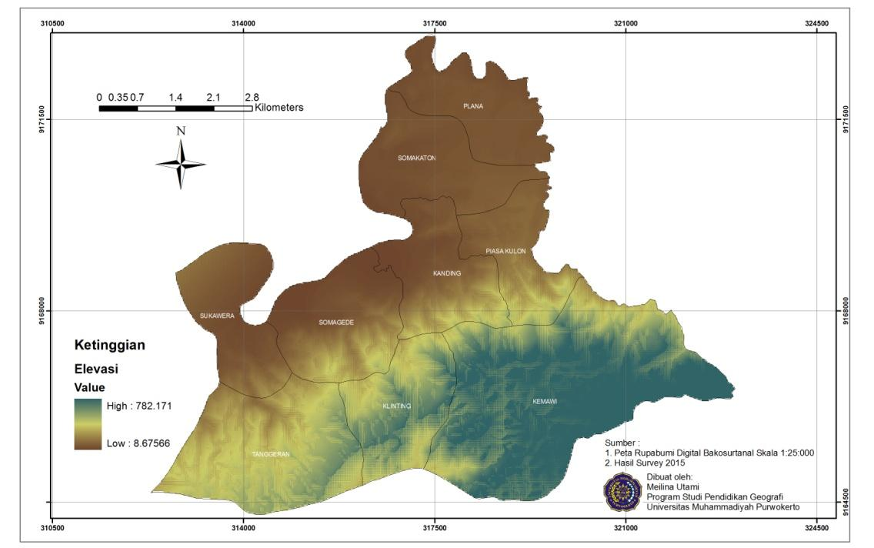
Source: Source, 2001
Figure 1. The Map of Somagede
For formula writing, the description part of the formula is written as follows
Equation 1 .......
A = −10log (1 − ($\frac{G × F × L × f^{0.5}}{8}$))……………. (Eq.1)
where: G – coefficient (the frequency-absorption factor of leaves), F – the surface area of leaves for unit volume, L – the depth of the tree, f – the frequency of the road-traffic noise

- Result and Discussion
Results should be clear and concise. The results should summarize (scientific) findings rather than providing data in great detail. Please highlight differences between your results or findings and the previous publications by other researchers. For tables, they are sequentially numbered with the table title and number above the table. Tables should be centered in the column and fit to window and tables and should be referenced in the relevant paragraph (......the figure as shown in Table 1.).
Table 1. Slope condition in Somagede
No | Slope (%) | Area
No | Slope (%) | Ha | %
1 | 0-8 | 11.052,54 | 26,83
2 | 8-15 | 2.231,46 | 5,42
3 | 15-25 | 1.362,02 | 3,31
4 | 25-45 | 18.429,10 | 44,74
5 | >45 | 8.111,97 | 19,70
 | Total | 41.187,09 | 100,00
Source: Source, 2015
- Conclusion
Conclusions should answer the objectives of research. Tells how your work advances the field from the present state of knowledge. Without clear Conclusions, reviewers and readers will find it difficult to judge the work, and whether or not it merits publication in the proceeding.
- Acknowledgments
Recognize those who helped in the research, especially funding supporter of your research

- References
Cite the main scientific publications on which your work is based. Cite only items that you have read. Do not inflate the manuscript with too many references. Avoid excessive self‐citations. Avoid excessive citations of publications from the same region. Check each reference against the original source (authors name, volume, issue, year). Please use Reference Manager Applications like EndNote, Mendeley, Zotero, etc. and use APA 6th style. All publications cited in the text should be included as a list of references. Please ensure that every reference cited in the text is also present in the reference list (and vice versa). (Bell MT, 10 pt, justify)

Example:

Batty, D., & Buchori, A. eds. (2001). Principle of Remote Sensing. Reading, Mass.: Addison- Wesley. ← Book
Brimicombe, A. (10 August 2011). Citing Internet sources URL http://www.eei- alex.com/eye/utw/96aug.html. ←Website
Clancey, W.J. (1979). Transfer of Rule-Based Expertise through a Tutorial Dialogue. PhD Dissertation, Department of Computer Science, Stanford University. ←Thesis
Clark, B.C (2011). AGB for Predicting Urban Growth. In Proceedings of the ISPRS, 200-210. Bali, Indonesia : International Conferences on Remote Sensing, Inc. ←Conferences
Dragicevic, S., Terence, L., & Shivanand, B. (2015). GIS-based multicriteria evaluation with multiscale analysis to characterize urban landslide susceptibility in data-scarce environments. Habitat International, 45(2), 114–125. [Crossref] ← Journal

